1. Introduction

School 452 is a member of the High School network and typifies the concerns that are present with other schools in similar circumstances. While there are other schools that are more concerning, School 452 is not an extreme case. Thus, conducting analysis on School 452 may provide more generalizable insights useful to other schools that are struggling with educational achievement goals.

1. Trajectory of Student Scores

An initial analysis of the data focuses on the mean student. The goal of the analysis is to observe the general trends present in the data. From 2013 to 2014, the mean scores increased: English scores increased by 8%, Math increased by 22%, Reading increased by 37%, and Science increased by 29%. However, these gains were lost in subsequent years. This negative would continue in subsequent years. This is observed in Figure 1, and the losses were distributed throughout all subjects.

Figure 1: Variation in Mean Score

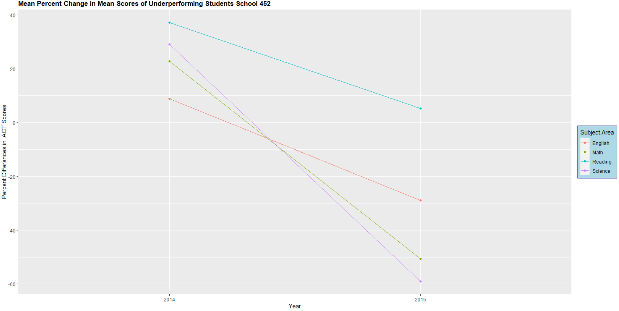

1. Demographic Analysis of Underperforming Students

A demographic analysis is also conducted to observe if there are particularly vulnerable students that are part of the underperforming cohort. An additional quantitative analysis supports this high-level analysis to assist in the creation of priorities. When observing gender and if one’s primary language was English at home, the results were not discerning. It appears that the distribution between male and female student is uniform. Additionally, the distribution of scores between native speakers and non-native speakers of English is also uniform. While these two demographics did not provide insights individually, observing their intersection did provide value. In Figure 2, the lower-quartile of the men that are non-native English speakers is lower than the other lower-quartiles of other demographics.

Figure 2

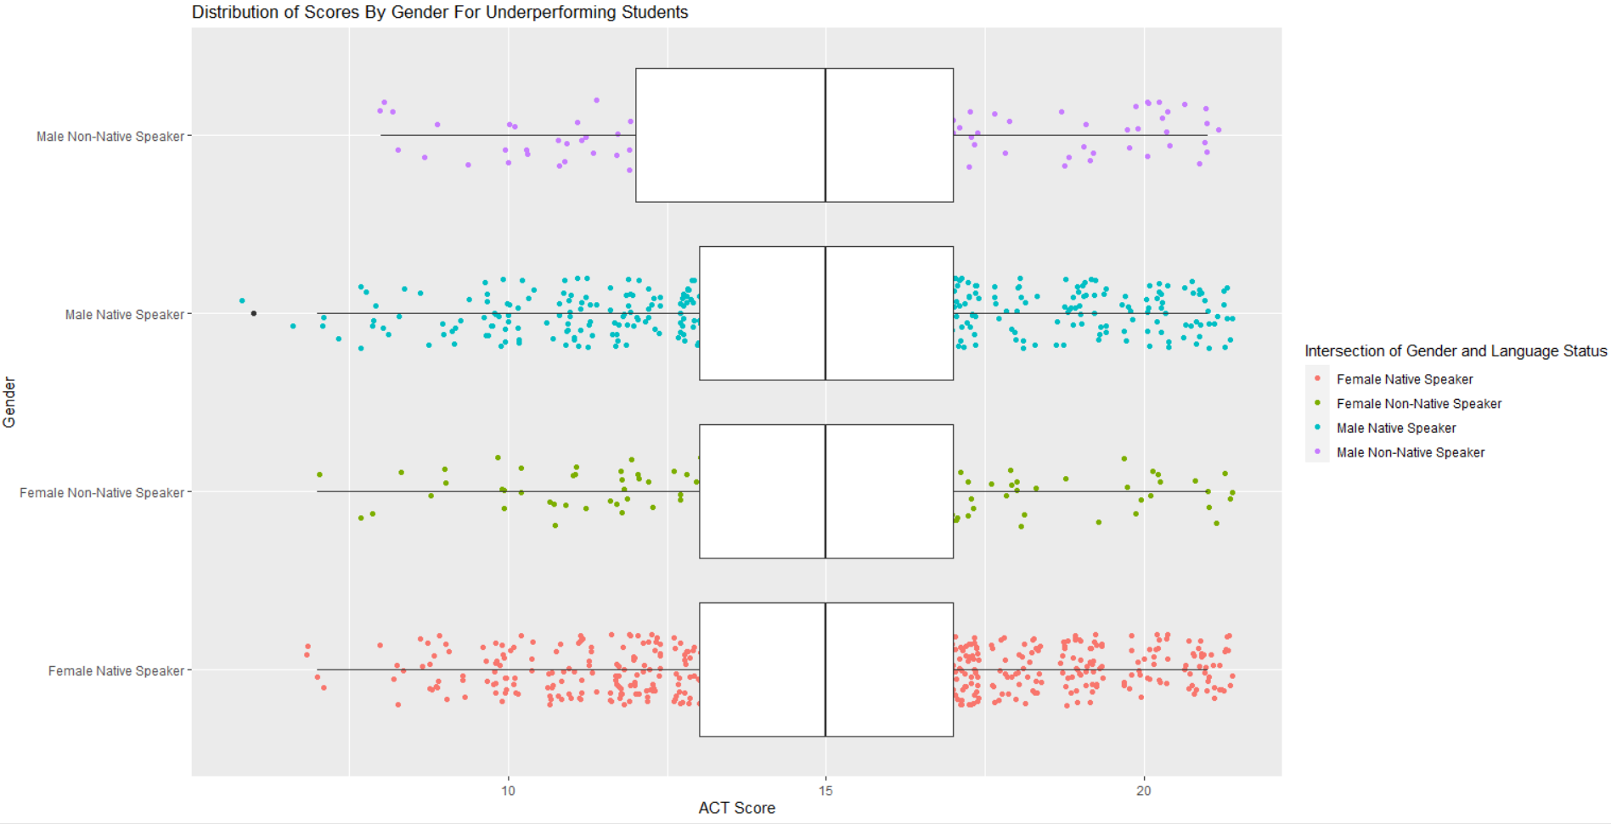

This suggests that there is a sub-population of students at this intersection that are performing at a lower level than other demographic groups of concern in a substantial manner.

Ethnicity is also under the purview of the analysis as a central demographic factor. American Indians appear to be the most underperforming demographic as their lower quartile is the lowest amongst demographic groups. The average scores for white and Asian ethnicities are about equal. However, the upper quartile for white students is higher than Asians. When reviewing the intersection of gender and ethnicity, additional concerns are elucidated. This is visualized in Figure 3.

Figure 3

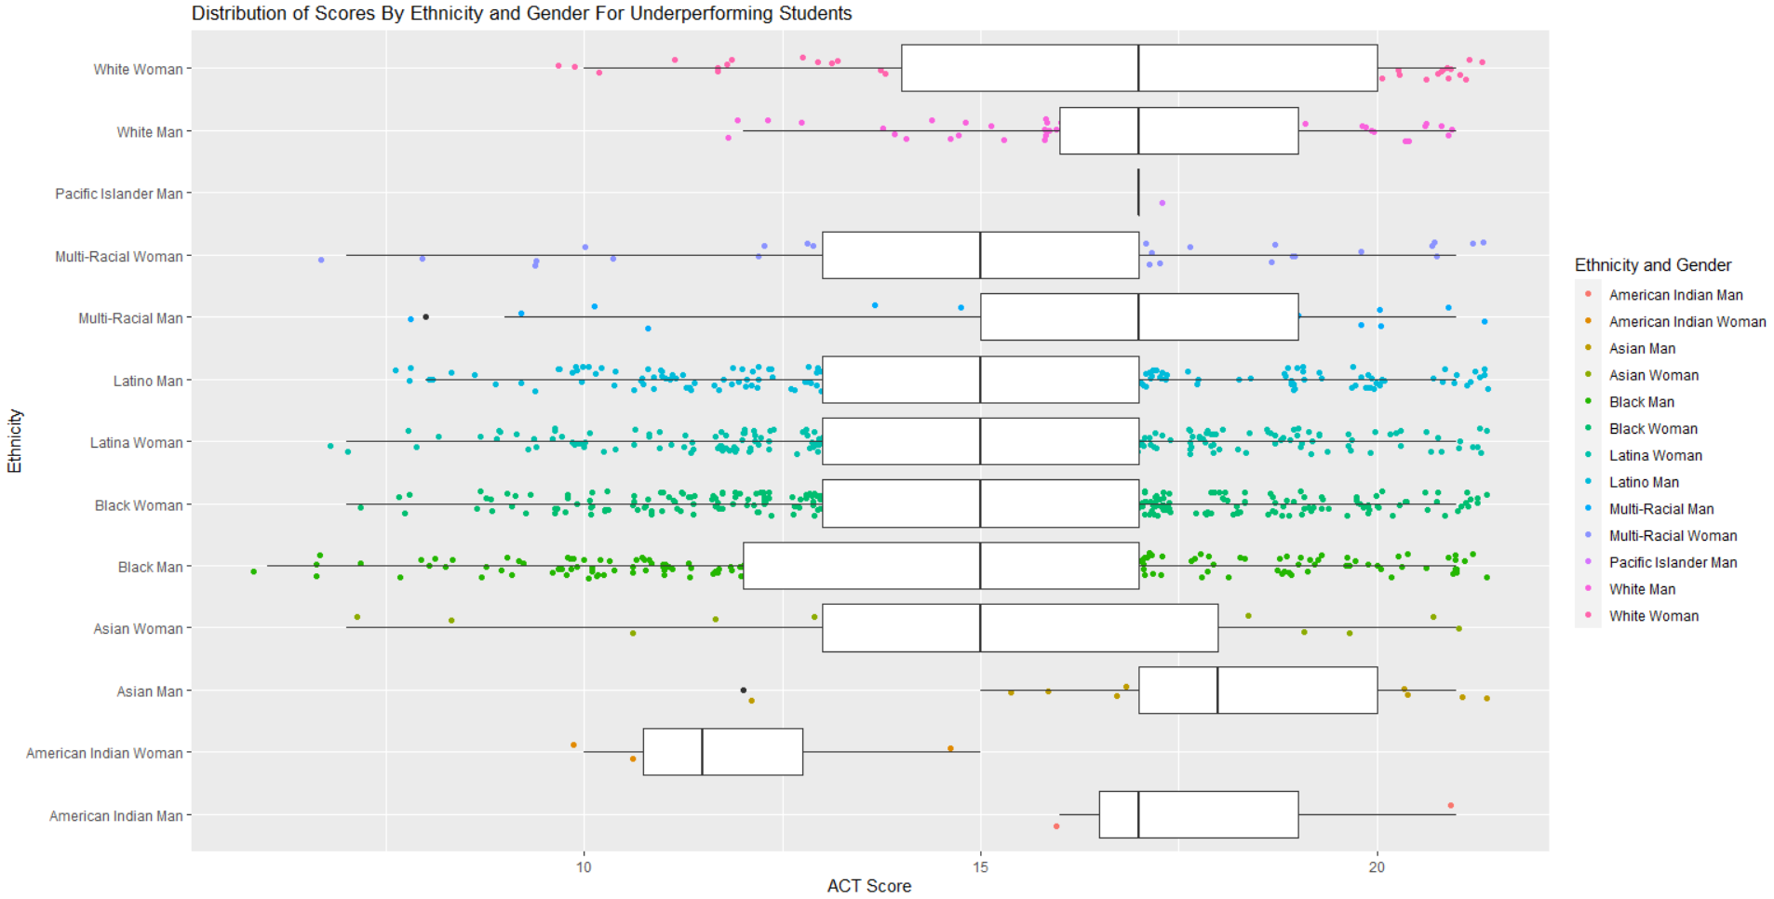

There is a disparity in the scores between Asian men and women; this may explain the difference in the quartiles compared to the white demographic as the scores of white men and women were more consistent. The disparity of Native American women and Native American men is also concerning. This relationship is particular in that Native American men are performant with the other demographics that typically perform well in spite being this cohort of concern. Thus, the disparity between genders within the Native American demographic and low scores of Native American women should be a point of emphasis in future decision making as gender may be the source of severe disparity.

IV. Regression Analysis

Lastly, regression analysis is conducted to support this more exploratory review of the data. The dependent variable is if a student performed at benchmark levels on the ACT. The data for this analysis included all students from the 2015 testing cohort for the ACT and is not subset to the student that are underperforming. The reason for this is make the data more generalizable with the analysis to be applied to schools facing challenges like School 452. The model used may be specified in the following equation.

$$\hat{Passing Benchmark} = \hat{β_{0} }+ {\hat{Genderβ}}_{1} + {\hat{Ethnicity β}}_{2} + {\hat{Native Speakerβ}}_{3} + ε$$

The passing benchmark variable is binary, and it encapsulates if a student achieved an 18 or higher in English and Science and a 22 or higher in Mathematics and Reading. Gender is a dummy variable and is encoded with a one for a student being male. Ethnicity is a dummy with the intercept term representing Native Americans that are female. The results of the regression are location in Figure 4 in the below.

Figure 4

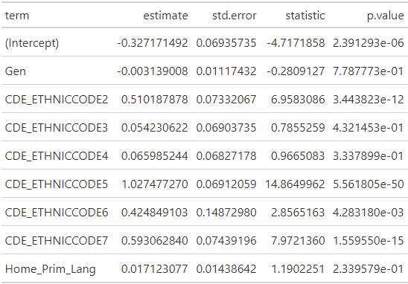

All the variables are significant and highlight racial disparities. The white demographic group is the most likely to bass the benchmarks. While, Native Americans are the least likely. Additionally, there is a negative relationship with being male and passing the benchmark. Additionally, native speakers perform statistically better than non-native speakers. This highlights the earlier insights of non-native English speakers that are male as being a particularly vulnerable group along with concerns with the Native American demographic.

V. Recommendation

To address the concerns of School 452, a greater priority may be to target non-native English speakers that are male and Native American woman. This is suggested in the demographic breakdowns and regression analysis. Given the schools lower English scores, this strategy is well supported in the data and the analysis and may be an expedient strategy to align with district initiatives more closely.